

Functional Requirements and conceptual Design for Call Log

Projects | USME – Ascent Rental Salesforce CRM Implementation
Prepared For | USME
Document Status | Issued

Document Change Control Log:
The Document Change Control Log is updated each time the document is modified. The log identifies the version number, the date of revisions, a brief description of the changes, and the author/reviewer
Version # | Date | Description | Author
V1.0 |  | Functional Requirements and conceptual Design | Durvah

Approvals from USME Team:
Version # | Date | Approver Role | Approver

Executive Summary
This document specifies what the new request register (today called the "call log") must do when USME moves from GoUSME to Salesforce and Ascent, must carry over. It is a companion to the Customer Portal FRD and uses the same priority scale. Where a requirement already exists there, this document points to its PRT number instead of repeating it.

Functional Requirements
Step | What happens today
1. Locate account | Caller gives account name and address. The CEC opens Partners and checks that the status is Active. If it is not Active, nothing is created: the request goes to the salesperson or to the customer updates team, who handle documents or a new account application.
2. Caller details | First and last name, department, phone (or email if none). If the caller is not in the list, the agent adds a new contact.
3. Equipment | MME (bulk): go to the cart and the model catalog, search, add several items; no price is shown. BTS (beds): patient information first, then preferred models, then catalog or packages.
4. Details and notes | Software version if the customer already has it, PO if provided, breakdown of equipment and accessories typed into notes, delivery location, billing department (required for MME).
5. Branch routing | The partner profile holds a service area that maps to a branch, set manually when the account is created. The branch to alert is shown. On the day the branch is notified by text; after hours the agent phones the on-call person.
6. Save | Saving sends an email to the caller (if the address is valid) and to everyone on the branch distribution list. The call log is Pending.
7. Branch handling | Each branch sees only its own call logs, selects one, assigns a CSR, and changes Pending to Active, or cancels. A team lead may see several branches. The assigned CSR sees it on the mobile device.
8. Substitution | The branch picks a compatible model, quantity and reason. The original line is cancelled and a new line added; the original is kept for audit and billing uses the original price.
9. Completion | No order exists until the branch confirms delivery. Once the call log shows delivered or completed, the order lines and billing start are built.

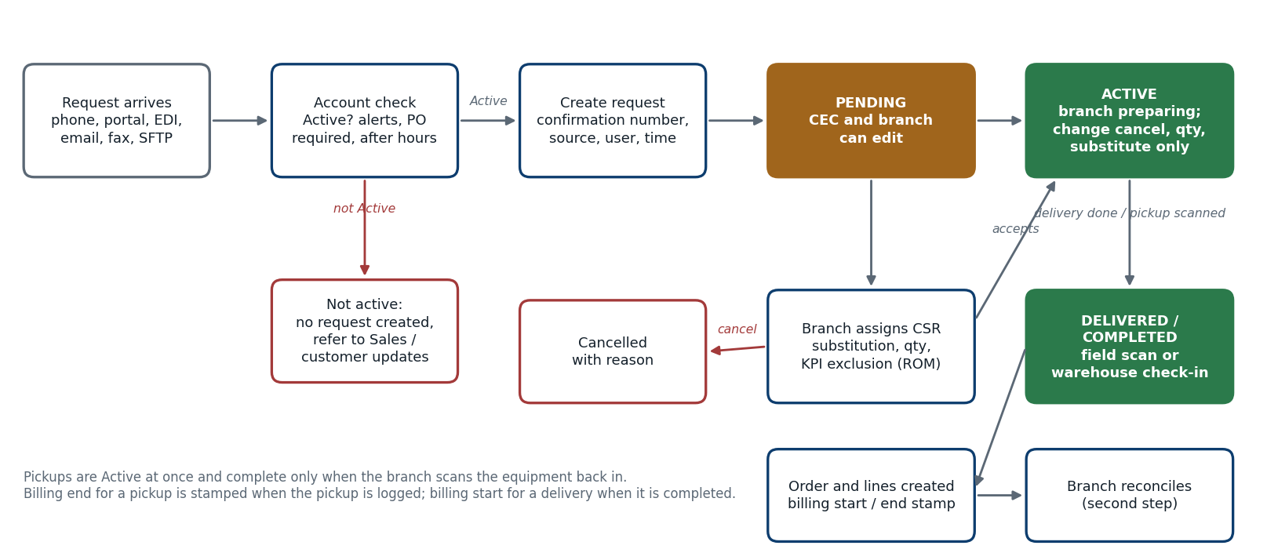
Figure 1. Request lifecycle from intake to reconciliation (legacy behavior carried into the new register)

Clarified terms and rules
Term or rule | Meaning
Swap | Replace an item with the same model, for a malfunction or a PM due. It records an exchange of the same item and creates one linked delivery and one linked pickup call log, with no price change.
Stand by | Drop off equipment at a location at no charge. It does not start a rental. Today it is a manual checkbox; the system does not set it automatically.
Exchange | The customer wants a different model. It is two separate, unlinked actions, and the customer pays any price difference. If USME's own stock shortfall forces a different model, the original contract price is kept.
Demo / loaner | A no-cost call log for equipment to be tested or reviewed, usually requested by BDRs or branches, with a start and end date.
Exclude from KPI | A checkbox used only by regional operations managers, before the status leaves Pending, for events such as bad weather that make a delivery miss the two-hour window.
Dates on a call log | Used only for a future delivery or a future pickup (for example a pickup on Friday called in on Monday). They are not used for past dates. They act as the start and stop dates. The earliest future date is the next business day; ASAP is the default (about 95%).
Pending vs Active | Deliveries start Pending Branch Confirmation. Pickups are Active at once. Nothing is complete until the branch checks the delivery off on its phone or system, or scans the equipment back into the warehouse. The branch then reconciles as a second step.
Billing stamps | A delivery always carries a billing start, stamped when the delivery is completed. A pickup always carries a billing end, stamped when the pickup is logged, not when it is collected. Before then the fields show as expected.
Preferred models | If an account has preferred models, the agent must choose from them and uses the full catalog only for items outside the list. They were set up by report: models ordered 15 or more times a month became each account's preferred list, entered by hand.
Packages | A package bundles a mattress, blower and frame (for example Freedom Advanced Wave XMS for bariatric) so the agent picks one line. A package carries one price for everything in it.

Call Log Request Register

A. Account validation and intake
ID | Requirement | Acceptance criteria
CLR-001 | Before any request is created the register checks the account status. A request cannot be created for an account that is not Active, whether it comes from the CEC, the portal, EDI or any other channel. | Attempt on an inactive account is blocked with a message naming the status; no record is created.
CLR-002 | For a non-active account the agent can send a referral to the account's salesperson or the customer updates team from the same screen, so the lead is not lost. The referral is a lightweight record, not a request. | Referral stores account, caller, request summary, user and time [Validate].
CLR-003 | The account search finds Active accounts by account number, name or address, and shows the account alert banner (for example facility type, "orders BTS only", delivery preferences) before the agent continues. | Alert text is visible without extra clicks and can be edited by authorized users.
CLR-004 | Accounts flagged "PO required" prompt the agent to ask for a PO. The prompt is a confirmation, not a block: if the caller has no PO the agent can continue. | Saving without a PO shows "continue without PO?" and succeeds on Yes (see PRT-205).
CLR-005 | All intake channels (CEC phone, portal, EDI, email, fax OCR, SFTP, Power Automate, API) create requests in the same register through one shared intake service, each stamped with source, originating user or system, time and any external reference. | Two requests for the same item from two channels are detected (see CLR-043); source is reportable.

B. Caller, contact and request type
ID | Requirement | Acceptance criteria
CLR-010 | The agent selects a caller from the account's contacts, or adds a new contact in place with name, phone and email. A request needs a phone or an email for confirmation. | New contact is saved on the account and selected on the request.
CLR-011 | The agent selects the caller's department. The billing department is selected separately and defaults from the department; it is mandatory for MME requests. | MME requests cannot be saved without a billing department.
CLR-012 | Request types: Delivery, Pickup, Swap, Stand by, Demo / loaner, Exchange, Unit transfer, Consignment start and stop. One request can hold deliveries and pickups together (the legacy screen shows both). | Each type has its own validation set and shares one request model.
CLR-013 | Equipment type (modality) is MME (bulk, department-linked, multi-item) or BTS (beds, patient-linked). BTS shows patient fields; MME does not. | MME has no patient fields; BTS requires them per CLR-020.

C. Patient data for BTS
ID | Requirement | Acceptance criteria
CLR-020 | BTS requests capture patient first and last name, weight, height, unit, and room, and always delivery location. Which patient ID, room and others are mandatory is configured per account; the screen marks required fields with an asterisk and does not ask for optional ones. | Fields marked required by account configuration block save; others do not.
CLR-021 | Patient identity stays in Salesforce. GoTransverse and Ascent receive a token only (see the tokenization requirements). | No patient name or ID appears in any outbound message to GT or Workato.
CLR-022 | The PO field accepts PO numbers only and warns that patient information must not be entered there. | Warning text appears next to every PO field (see PRT-218).

D. Equipment selection
ID | Requirement | Acceptance criteria
CLR-030 | If the account has preferred models the agent must pick from that list first and can open the full model catalog only for items outside it. The preferred list is shown first by default. | Catalog access is logged when a non-preferred model is chosen [Validate].
CLR-031 | Packages add all component lines (for example mattress, blower, frame) with one action. The agent asks the caller standard or pediatric and selects the matching package. A package carries one price for the group. | All components appear as lines under the package parent.
CLR-032 | Each model shows mandatory and optional accessories. The agent can untick an accessory the hospital already has. Optional accessories support upselling. Accessories are structured lines, not typed notes. | Delivered accessories are listed on the request so all can be collected at pickup.
CLR-033 | Software version or option can be recorded when the customer already has one. | The selected version is stored on the line.
CLR-034 | The register shows no price to the agent for rental lines unless the role allows it; daily rate is visible only where today's screen shows it. | Price visibility follows the role and is confirmed with USME (question 5).
CLR-035 | At order entry the agent sees whether the item is available at the fulfilling branch by the delivery date. Today there is no inventory visibility. | Availability indicator from Ascent inventory; if unknown, says so [Validate].
CLR-036 | Quantity and a note are captured per line. Free-text notes may still hold extra instructions but do not replace structured lines or accessories. | Line list matches what the branch will deliver.

E. Delivery and pickup details
ID | Requirement | Acceptance criteria
CLR-040 | Delivery defaults to ASAP. A future date is allowed from the next business day. Dates are used for future delivery or future pickup only, and past dates are rejected. | Date earlier than next business day is rejected; ASAP stores the request time.
CLR-041 | Delivery location (unit, room, department, contact) is captured. The delivery address comes from the account's stored addresses; an account normally has one. | Address cannot be free text.
CLR-042 | A pickup request lists the account's current rentals so the agent picks the items to collect. If an item is not in current rentals it cannot be picked up. At pickup the system shows the last recorded room or unit and the agent reconfirms it verbally. | No pickup can be created for equipment not on rent at the account.
CLR-043 | Duplicate prevention: an item already called off by any channel cannot be called off again. The message names the existing request. | Phone and portal requests for the same item produce one pickup (PRT-502).
CLR-044 | A pickup carries a reason (for example Usage Completed, PM Due), a rental stop date and a pickup date and time. The reason list is managed by USME. | Billing end uses the rule in CLR-062 [Validate].
CLR-045 | Delivery and handling instructions are free text (for example deliver to a floor or a different entry). | Instructions appear on the branch and mobile views.

F. Branch routing, assignment and alerts
ID | Requirement | Acceptance criteria
CLR-050 | The fulfilling branch is derived from the account's service area and delivery address, not chosen by the agent. Service area on the account is maintained under a governed process, with a report for accounts whose branch is disputed. | Branch shows read-only on the request; changing the service area is audited.
CLR-051 | Saving sends an email to the caller (valid email only) and to the branch distribution list. In the daytime the branch also gets a text. After hours, the agent can see who is on call and escalate by phone. | Notification log records recipients, channel and time.
CLR-052 | The agent can add a note for the branch (for example to a named person). | Note is visible to the branch with the request.
CLR-053 | Each branch sees only its own requests. Team leads and master users can see several branches. A branch user selects requests and assigns them to a CSR from that branch. The assigned CSR sees the request on the mobile device. | Visibility follows branch membership; assignment is audited.
CLR-054 | The register can later show a request to the branch before the delivery date so the branch can plan, without making it Active. | To be confirmed.

G. Status and editing
ID | Requirement | Acceptance criteria
CLR-060 | Statuses: Pending (Pending Branch Confirmation), Active, Delivered or Completed, Canceled. Deliveries start Pending; pickups start Active. The customer sees the legacy status names | Status history is kept with user and time.
CLR-061 | In Pending, the CEC and the branch can edit the request. In Active, lines cannot be added, but quantity can change, lines can be cancelled and a model can be substituted. Cancelling after Active needs a reason. | Add line is disabled in Active.
CLR-062 | Billing start is stamped when a delivery is completed; billing end is stamped when a pickup is logged (not when collected). Before the event the fields show as expected. Neither is typed by the agent. | Stamps are sent to GT as separate start and stop events.
CLR-063 | Completion happens only when the branch confirms delivery (phone or system) or the warehouse scans pickup equipment back in. On completion, order lines and billing are created; before that the order lines are empty. | No billing event exists for a Pending request.

H. Substitution, swap and exchange
ID | Requirement | Acceptance criteria
CLR-070 | Substitution lists compatible models for the line, asks for quantity and a reason, cancels the original line, adds the substitute and keeps both for audit. Billing uses the original contract price when USME forces the change. | Original line shows Substitution and stays on the request.
CLR-071 | Substitution is controlled by rules at model level and account or contract level (preferred models, accessories, and models a customer will not accept). Some contracts, such as government or VA accounts, forbid substitution. The rule set is maintainable as terms change. | An ineligible substitution is blocked or needs an approved override.
CLR-072 | A swap creates one linked delivery and one linked pickup for the same model, with a reason such as PM Due and no price change. Both show as a pair in every list and the pair shows both completion times. Delivery cannot be completed until the paired pickup is done. | The pair indicator is visible in list views, not only inside the record.
CLR-073 | A swap can substitute a different model when the same model is not available, without cancelling and redoing it. | Legacy limitation removed [Validate].
CLR-074 | Packages can be substituted line by line or replaced by another package without cancelling the request, with the price rule for packages confirmed by USME. | Wrong packages can be corrected in Pending or Active (question 6).
CLR-075 | An exchange (a different model chosen by the customer) creates two unlinked actions and prices the difference to the customer. The branch is alerted. | Price difference is reported to Billing.

I. Stand by, demo, consignment and unit transfer
ID | Requirement | Acceptance criteria
CLR-080 | A stand by request delivers equipment with no charge and without starting a rental. The stand by flag is set by the system when the request type is Stand by or the account is a stand by account; it is not a manual checkbox that can be forgotten. | No billing start is created for stand by.
CLR-081 | A demo / loaner request carries a start and end date, creates no charge, and is flagged so it is excluded from rental billing. | Demo lines never reach GT billing.
CLR-082 | Consignment can be enabled per item as well as per account. The hospital starts and stops billing on consignment items by request; the register stamps the effective date and time (see PRT-404, PRT-410). | Per-item consignment flag is available; start and stop are audited.
CLR-083 | Unit transfer is a billing-only request that stops billing for the old unit on the transfer date and starts the new unit the next day, with no delivery or pickup task (see PRT-403). | Transfer history shows beside the unit field.

J. KPI exclusion, incidents and audit
ID | Requirement | Acceptance criteria
CLR-090 | Exclude from KPI is available only to the regional operations manager role, only while the request is Pending, and requires a reason. | Other roles do not see the control;
CLR-091 | Equipment failures are reported in the system with the three categories (failure before use, on-patient failure with harm, on-patient failure without harm), linked to the order, item and rental. The structured performance form fields (who was present, property loss, injury or death, timing of failure, notes, replacement status) are captured on a case, not by email. | Case links to the item and rental record and keeps history (see PRT-604).
CLR-092 | The CEC can correct patient name, patient ID and PO number on an active rental in the same way portal users can (update details), instead of asking billing to fix it in the back end. | Before and after values, user and time are stored (see PRT-402).
CLR-093 | Every request keeps an audit trail: creation, edits, assignment, status changes, substitutions, cancellations, KPI exclusions and who did them. | Trail is read-only and exportable.

Open Questions:
- Support and Rental Service Request, need more information on how is it currently handled – IT Tam Business and Ascent
- Work Orders Process from Intake - Ascent
- Is Tokenization required on Intake? – IT Team

Design

Data Model

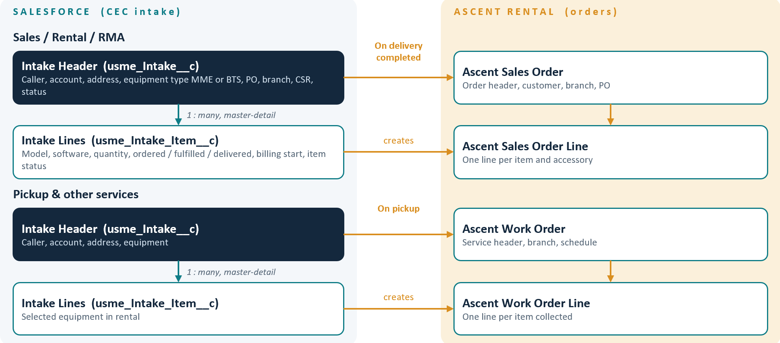
Object & Field Mapping Reference
This section documents the underlying Salesforce object architecture and complete field mapping for the Call Log Request Register solution. The model is structured as a 1:N Master-Detail relationship between the Header object (usme_Intake__c) and the Child Line Item object (usme_Intake_Item__c). All custom fields utilize the standardized prefix usme_.

1. Parent Header Object: Intake (API: usme_Intake__c)
The Intake header object manages overall request metadata, caller details, fulfillment dates, PO authorization, branch routing, and dynamic BTS delivery details.
Field Label | API Name | Data Type | Target Object / Rule | Description & ERD Role
Intake Number | Name | Auto Number | - | Primary Key (PK) / Unique Identifier
Record Type | RecordType | Record Type | - | Record Types: Rental, Sales, RMA, Pickup
Sub Type | Usme_intake_subtype | Picklist | -
Intake Source | usme_Intake_source__c | Picklist | - | Origin channel (Default: Inbound Call / Phone, customer Portal, EDI, Fax, Email, RPA , SFTP)
Status | usme_Status__c | Picklist | - | Fulfillment status: Pending, Active, Delivered/Completed, Cancelled
Partner | usme_Partner__c | Lookup | Account | Foreign Key (FK) to Account (Must be Active per CLR-001)
Caller | usme_Caller__c | Lookup | Contact | Foreign Key (FK) to Contact
Department | usme_Department__c | Text / Picklist | - | Caller department selection
Phone | usme_Phone__c | Phone | - | Contact phone number
Extension | usme_Extension__c | Text | - | Phone extension
Email | usme_Email__c | Email | - | Contact email address
Call Date Time | usme_Call_Date_Time__c | Date/Time | - | Timestamp of call intake (with timezone offset)
Delivery/Pickup Address | usme_Delivery_Address__c | Lookup / Text Area | - | Destination address for delivery or pickup location
Demo/Loaner | usme_Demo_Loaner__c | Checkbox | - | Flag for Demo/Loaner request (CLR-081)
Equipment Type | usme_Equipment_Type__c | Radio / Picklist | - | Modality selection: MME or BTS
Patient First Name | usme_Patient_First_Name__c | Text | Mandatory for BTS | BTS Patient First Name
Patient Last Name | usme_Patient_Last_Name__c | Text | Mandatory for BTS | BTS Patient Last Name
Patient Id | usme_Patient_ID__c | Text | Optional | BTS Patient Identifier / MRN
Patient Height | usme_Patient_Height__c | Number | Optional | BTS Patient Height value
Patient Height Unit | usme_Patient_Height_Unit__c | Picklist | cm / in | BTS Height Unit selection
Patient Weight | usme_Patient_Weight__c | Number | Mandatory for BTS | BTS Patient Weight value
Patient Weight Unit | usme_Patient_Weight_Unit__c | Picklist | kg / lbs | BTS Weight Unit selection
Unit | usme_Unit__c | Picklist / Text | Mandatory for BTS | Hospital Unit / Ward selection
Cost Center | usme_Cost_Center__c | Text | Optional | Facility Cost Center / Billing code
Delivery Location/Room Number | usme_Delivery_Location_Room_Number__c | Text | Optional | Room Number / Exact Delivery Location
Patient Kind | usme_Patient_Kind__c | Picklist / Text | Mandatory for BTS | BTS Patient Kind / Clinical Category
Expected Delivery Date Time | usme_Expected_Delivery_DT__c | Date/Time | Mandatory | Requested delivery slot date & time
ASAP Delivery | usme_ASAP_Delivery__c | Checkbox | - | Earliest available slot indicator (Defaults True)
ASAP Delivery Time | usme_ASAP_Delivery_Time__c | Picklist | - | Dropdown time selection when ASAP Delivery is checked
PO Override | usme_PO_Override__c | Checkbox | - | Bypass PO requirement flag (CLR-004)
PO # | usme_PO_Number__c | Text | - | Purchase order reference number
Fulfill Branch | usme_Fulfillment_Branch__c | Lookup | Branch / Location | Primary Servicing Branch (Derived via Service Area)
Sales Order | usme_Order__c | Lookup | Order | Foreign Key (FK) linking Call Log to generated Sales Order
Comments | usme_Comments__c | Long Text Area | - | Detailed call / handling notes

2. Child Line Item Object: Intake Item (API: usme_Intake_Item__c)
The Intake Item child object manages individual product requests, quantity counts, warehouse branch sourcing, substitution history, and Order Item links.
Field Label | API Name | Data Type | Target Object / Rule | Description & ERD Role
Intake | usme_OrderIntake__c | Master-Detail | usme_Intake__c | Foreign Key (FK) - Parent Record (1:N Master-Detail)
Model Common Name | usme_Product__c | Lookup | Product2 | Foreign Key (FK) to Standard Product catalog
Order Quantity | usme_Quantity__c | Number | - | Requested equipment line-item count
Fulfill Quantity | usme_Fulfill_Quantity__c | Number
Delivered Quantity | usme_Delivered_Quantity__c | Number
Equipment Type | usme_Equipment_Type__c | Picklist | - | Values: MME, BTS
Branch | usme_Branch__c | Lookup | Branch / Location | Fulfilling Warehouse Branch per line item
Sales Order Product | usme_Order_Product__c | Lookup | OrderItem | Foreign Key (FK) linking item to standard Sales Order Line Item
Item Status | usme_Item_Status__c | Picklist | - | Status of individual item line (Pending, Active, Substituted, Cancelled)
Stand By | usme_Stand_By__c | Checkbox | - | Flags equipment delivered at no charge without starting a rental (CLR-080).
Swap | usme_Swap__c | Checkbox | - | Identifies a same-model equipment swap; linked delivery and pickup are managed per CLR-072.
Model Options | usme_Model_Options__c | Picklist / Multi-Select Picklist | - | Selected model option(s) for the requested equipment line. Confirm whether single- or multi-select is required.
Software Version | usme_Software_Version__c | Picklist / Text | - | Software version recorded when the customer already has one (CLR-033).
Department | usme_Department__c | Picklist / Text | - | Department associated with the requested equipment line, as shown on the intake screen.
Expected Billing Start Date | usme_Expected_Billing_Start_Date__c | Date | - | Expected billing start date for the equipment line; actual billing start is stamped when delivery is completed (CLR-062).
Delivery Notes | usme_Delivery_Notes__c | Long Text Area | - | Free-text delivery and handling instructions for the branch (e.g., floor, entry, or other delivery directions); visible to branch and mobile users (CLR-045).
Type of Action | usme_Type_of_Action__c | Picklist |  | Type of Action like Filled Late, Turn Down & Cancel
Performers / Profiles
- CEC Team Members
- Branch
- CSR
Functional Process
- Create Intake and Manage Intake
- Intake List View
- Assign Intake to CSR by Branch
- Background Triggers/API to create Sales Order and Work Orders
- Sales Order List View
- Work Order List View
Call Log Intake: Process Flow

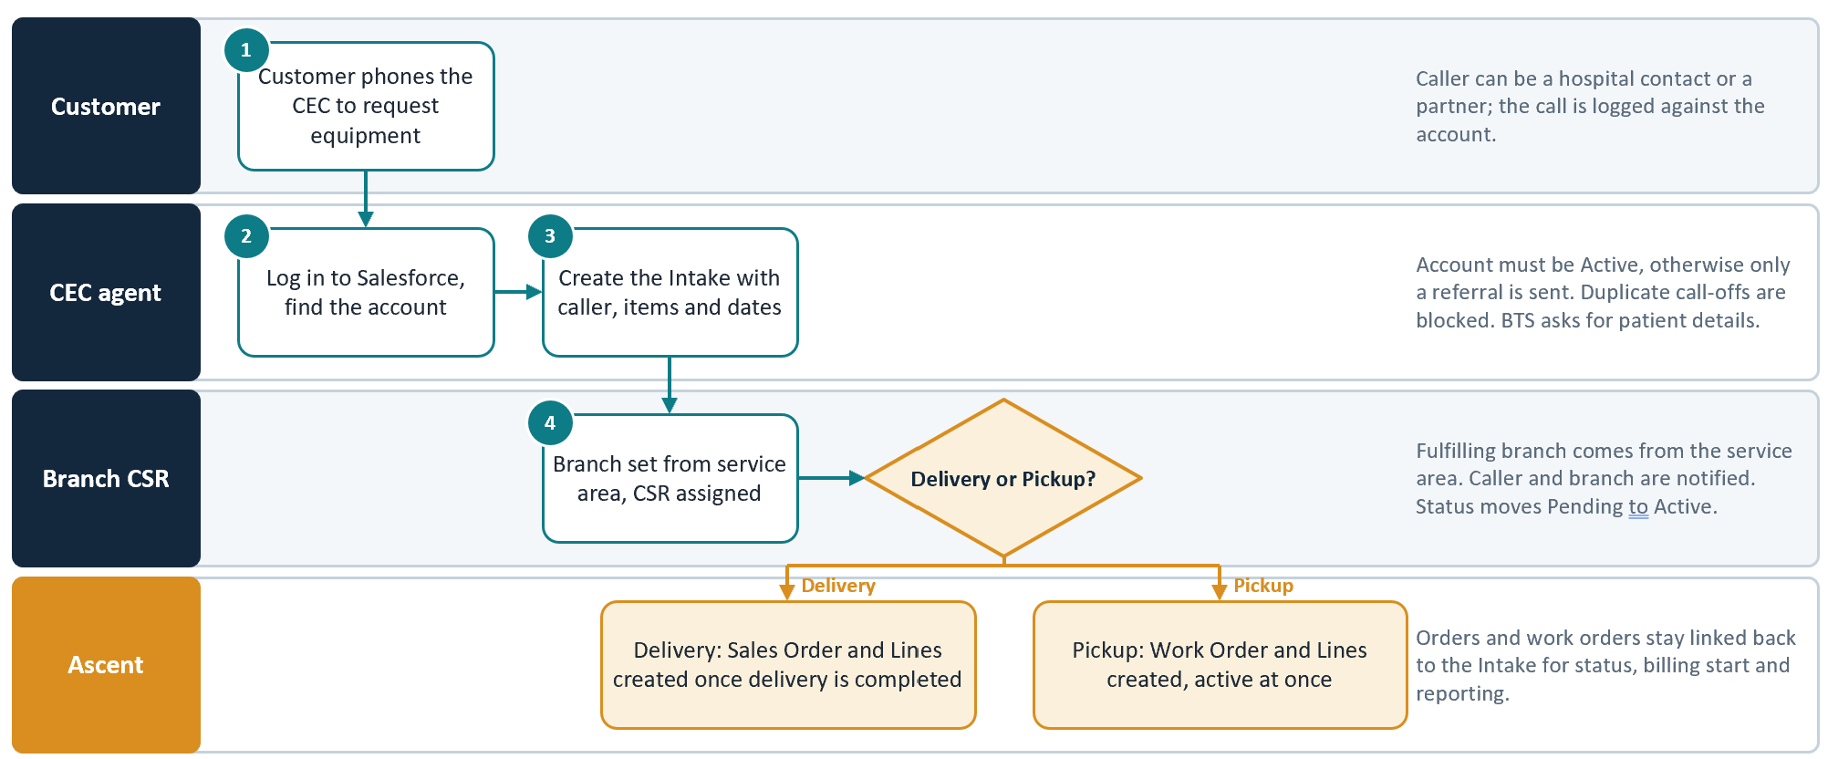

Intake Request Lifecycle and Business Rules

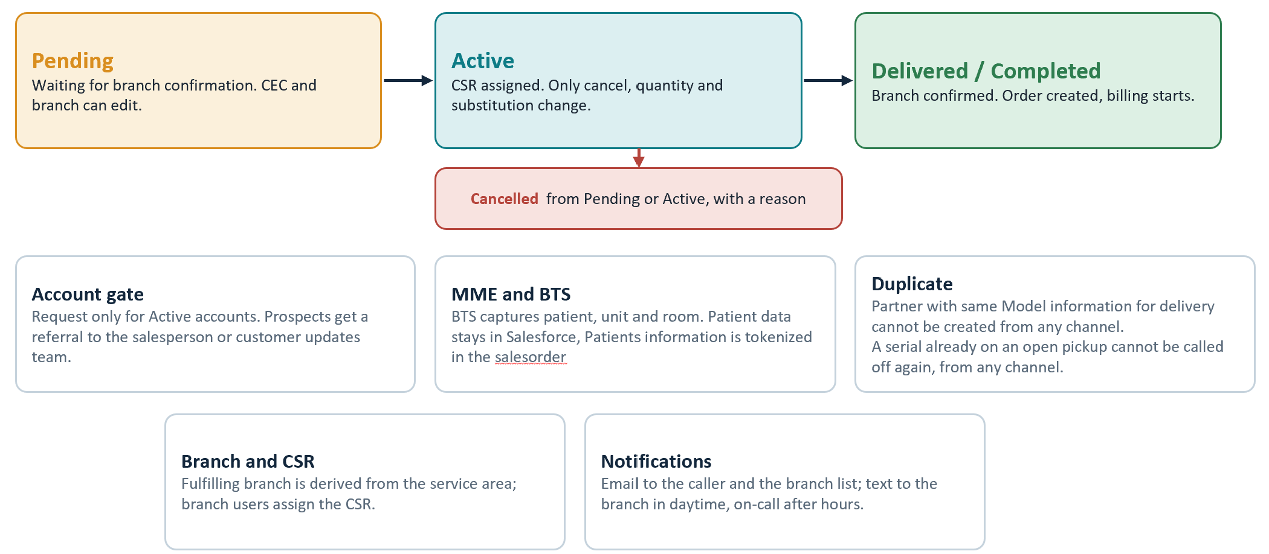

Technical Implementation & Build Architecture Guide
This section outlines the complete technical execution strategy, platform components, automation flows, and integration architecture required to build the USME Call Log Request Register in Salesforce.

1. Salesforce Core Architecture & Security Model
A. Custom Data Model Creation
1. Create Custom Object usme_Intake__c (Label: Intake / Request Register). Enable Track Field History, Allow Search, and Grant Access to API.
2. Create Custom Object usme_Intake_Item__c (Label: Intake Item). Set usme_Intake__c as Master-Detail relationship field on usme_Intake_Item__c with Read/Write sharing settings.
3. Deploy all custom fields with prefix usme_ as defined in the Data Model section above.
B. Record Types & Page Layouts
1. Define Record Types on usme_Intake__c: Call Log, Rental Request, Sales Request, and RMA Request.
2. Configure Dynamic Forms on usme_Intake__c Lightning Record Pages to conditionally render section layouts based on usme_Equipment_Type__c (MME vs BTS).
C. Role Hierarchy & Sharing Architecture
1. Set Organization-Wide Defaults (OWD) for usme_Intake__c to Private.
2. Implement Criteria-Based Sharing Rules: Share usme_Intake__c records with Branch Public Groups based on usme_Fulfillment_Branch__c.
3. Grant Regional Operations Managers access to KPI Exclusion fields via Field-Level Security (FLS) and Permission Sets.
2. User Interface (UI) Implementation
A. Lightning Web Component (LWC): Call Log Intake Screen
1. Build a custom single-page Lightning Web Component (c-call-log-intake) replacing the GoUSME legacy UI.
2. Top Bar & Alert Banner: Dynamically query Account record upon selection. Display LTAC Facility alerts and PO Required warnings in a high-visibility alert header.
3. Real-time Account Check: Execute CLR-001 validation via Apex controller. If Account.Status != 'Active', lock intake form and display Lead Referral modal (CLR-002).
4. Conditional BTS Section: Dynamic rendering logic exposes Delivery Details (Patient Name, Weight, Height, Unit, Cost Center, Room) when Equipment Type = BTS.
5. Request Cart: Interactive datatable allowing multi-item additions, preferred model filtering (CLR-030), package expansion (CLR-031), and accessory selections (CLR-032).

3. Automation & Business Logic (Salesforce Flow & Apex)
A. Record-Triggered Flows
1. Intake Validation & Routing Flow (Before Save):
- Derive usme_Fulfillment_Branch__c from Account Service Area mapping (CLR-050).
- Auto-calculate expected delivery dates and validate business hour prompts (CLR-005).
2. Intake Notification Flow (After Save):
- Send email confirmation to Caller upon save (CLR-051).
- Trigger SMS notification via Workato/Twilio to Branch distribution list for daytime requests; invoke On-Call phone alert for after-hours requests.
B. Apex Trigger & Controller Framework
1. IntakeTrigger & IntakeTriggerHandler:
- Duplicate Prevention Logic (CLR-043): Query active rental items to prevent duplicate call-offs across channels.
- Substitution Validation Engine (CLR-070, CLR-071): Validate contract substitution rules before allowing model swaps in Active status.
- Tokenization Service (CLR-021): Strip/tokenize patient PII before outbound integration payload assembly.
2. Order Creation Engine (CLR-063): On status change to Delivered / Completed, create standard Salesforce Order and OrderItem records.
4. Implementation Phase Roadmap
1. Core Setup & Data Model - Object creation, field deployment, FLS, and page layouts.
2. UI & Intake LWC - LWC intake screen, alert banners, cart management, and BTS dynamic fields.
3. Automation Logic - Flows, Apex triggers, duplicate prevention, and substitution rules.
4. Integrations - Workato middleware setup, Ascent native inventory configuration, and GoTransverse billing sync.
5. Testing & Deployment - UAT, role-based security validation, and go-live cutover.

